Functional Design

Stenden Help Desk

IT1A

## Table of Contents

**Introduction** **3**

**Description of New System** **4**

**Data Model** **5**

**Desired Output** **6**

**Required Input** **10**

**Menu Structure and Organisation** **12**

**Organisational Consequences** **13**

**Technical Consequences** **14**

## Introduction

The functional design contains the explanation of the solution that was described in the project plan or the preliminary research. This functional design contains the design for the new developed system.

Our programmers will develop the software for this information system based on this functional design. A functional design should give the functional designer or the information analyst a view to understand the given software. It also guides the developers to the wanted software. The functional design is also known as a system design.

A functional design presents a precisely view to the client and what the information system will look like and contain. It will provide sufficient information to the technical developer or designer to make program the software. The functional requirements are described as precisely as possible. It is important for the support and for a good contract between both parties.

The purpose of this project is to create a ticket system of Stenden E-Help to get an overview about the problems from the clients. Also, it is important for Stenden to verify if a customer has a maintenance-license, because just in this case they are able to get support. Customers without a maintenance license should be redirected to purchase the maintenance license. The volume of calls and emails should decrease and the information should be saved in the Support-Desk.

Stenden is a company which produces financial management software for clients with min. year long maintenance license. The head of department, Rene Laan, manages all the projects for Stenden. The financial management software is the company’s main produced software. Stenden sells software and maintenance licenses for their financial software and advertised and distributing them by the sale department. The Stenden E-Help Desk department and its team leader Rene Laan are responsible for the collection and submitting the incidents for client with an active maintenance product.

Rene Laan conceived this project with the purpose to solving the stated issues with the E-Help department’s workflow. The software should help the department to achieve this Goal. IT1A will develop the product and testing will be done by Stenden E-Help employees. To receive a real feedback with problems right from the department.

Stenden will provide a funding for the project to IT1A. After the product is finalized and handed off to the company Stenden, the IT-Department is responsible for the hosting. IT1A will provide support for the given software for a dedicated period.

## Description of New System The Required Ticket-Management System for the Company Stenden E-Help will contain the following Aspects:

## A web based application for the users (Frontend)

## A database for saving the inputted data (Backend)

## Different accounts for the clients and superuser (hierarchical layers) with specific privileges to access/modify and delete the data

## Permissions

## There are the following permission levels for the given User-Profiles:

## Client (Maintenance License):

## The Client who owns a active maintenance license of Stenden can open a ticket in the Stenden E-Help. He also has the ability to view the FAQ, Login-Page and to submit the ticket.

## After submitting a ticket, it goes to the Stenden E-Help employees to work on the problem.

## Employee:

## An employee of Stenden E-Help is able to view all the tickets. They also can assign them to the administrators.

## Admin:

## The admin has unlimited access/permissions to the given system.

## Security:

## The security chief has the highest level to access the employees and user-accounts.

### Page-Layout

## The pages for the frontend user-interface will be broken into the following pages:

## Login Page:

## Clients have the ability to enter their login-details.

## Companies can enter their ID, company name or email.

## FAQ:

## A overview of common issues and problems with solutions.

## Clients can provide feedback if the solution was helpful for them.

## Information Page:

## An overview of the saved information of a company or client. The client is able to update their information.

## Clients can view and edit the list of their registered employees.

## Ticket Submission History:

## A table that shows the tickets that were submitted by the client in the past. This table is sortable by headings: TicketID, TicketName, Date Submitted, Employee Assigned and Ticket Status. This page offers the clients more details.

## Ticket Submit Page:

## Just Client with a active maintenance license are able to submit tickets in the Stenden E-Help Support Desk. They can enter the name, client-employee and description of the problem.

## If clients without maintenance license will be redirected to another web-page of the sale department.

## 

## Client-Employee Ticket Overview:

## This Page offers a overview with all the submitted tickets. The table will list 40 results per page, is sortable and filterable by the headings: TicketID, TicketName, TicketCategory, DateSubmitted, TicketStatus, CompanyName, EmployeeAssigned.

## Ticket View Client-Employee:

## As the employees are logged in, they have the ability to view the ticket in detail and modify it.

## Client-Employee Overview:

## Administrators of Stenden E-Help are able to access the overview of the employee accounts. They can add or remove employees.

## Employee-Page:

## All Information about an client-employee.

#### Main Procedure

## The main procedure of the Ticket-System:

## Lifecycle of a Ticket:

## User fills in:

## Ticket Name

## Description of the Problem

## Name of the Client-Employee who is submitting

## 2) After submitting the ticket and there are all fields sufficiently filled out, the client-employee will receive a Message: “Opened Ticket #1235 Problem”

## 3. If the Client-Employee finds his Problem in the FAQ, he is able to Set the Ticket-Status to “3. Solution”.

## 4. If the employee test the solution successfully, the “TicketStatus” will be set to “4. Confirmed”. If it doesn’t work they mark it as “TicketStatus 2. Open”

## 5. The employee can close the ticket or post another solution with “5. Closed”

## 6. The ticket-status can be manually changed by the assigned Client-Employee.

## 

#### Main Procedure

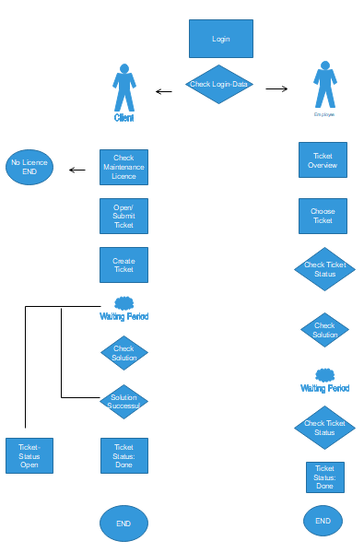

## Data Model

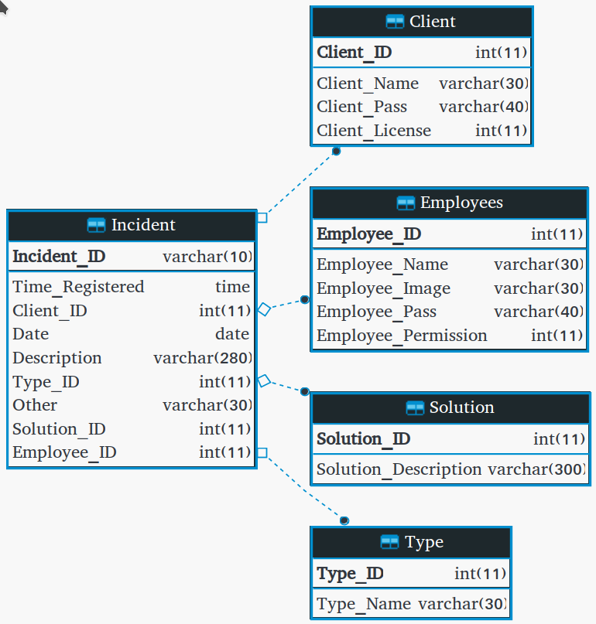

|  |  |
| --- | --- |
| Name | Incident |
| Description | All the information about the Incidents that is available. |

|  |  |
| --- | --- |
| **Attribute** | **Description** |
| Incident_ID | The identifying number of the incident (for record keeping purposes). |
| Time_registered | The time of the creation of the ticket. |
| Client_ID | ID of the client who created the ticket. |
| Date | Date of the creation of the ticket. |
| Description | Description of the incident. |
| Type_ID | Type of the incident |
| Other | If the Type_ID is 0, because the incident could not fit into the predefined categories, this is the Type. |
| Solution_ID | ID of the solution for the incident (null if there’s no solution). |
| Employee_ID | ID of the assigned Employee (null if no one is assigned). |

|  |  |
| --- | --- |
| Name | Client |
| Description | Information about the client. |
| **Attribute** | **Description** |
| Client_ID | The identifying number of the client. |
| Client_Name | Name of the client. |
| Client_Pass | Encrypted password of the client. |
| Client_License | Type of the client’s license. |

|  |  |
| --- | --- |
| Name | Employee |
| Description | Information about the employee. |
| **Attribute** | **Description** |
| Employee_ID | The identifying number of the employee. |
| Employee_Name | Name of the employee. |
| Employee_Image | Path to the image of the employee. |
| Employee_Pass | Encrypted password of the employee. |
| Employee_Permission | Permission system for the employees. |

|  |  |
| --- | --- |
| Name | Solution |
| Description | Solution for one or more issues. |
| Attribute | Description |
| **Attribute** | **Description** |
| Solution_ID | The identifying number of the solution |
| Solution_Description | Description of the solution. |

|  |  |
| --- | --- |
| Name | Type |
| Description | Type of an incident. |
| **Attribute** | **Description** |
| Type_ID | The identifying number of the type/category. |
| Type_Name | Name of the type/category. |

## 

## 

## 

## 

## 

## 

## 

## 

## Desired Output

|  |  |
| --- | --- |
| **Name:** | Ticket input |
| **User:** | Customer / Admin / Employees |
| **Objective:** | Ability for the customer to input their issue with the software through a ticket. |
| **Frequency:** | Often |
| **Sorting:** | N/A |
| **Selection:** | Client_Name, Client_role, Client_number, Date, Time_registered, Description, Type |
| **Data to be printed:** | N/A |

|  |
| --- |
| Thank you for submitting your ticket.    Please be patient while we put you in contact with one of our employees. |

|  |  |
| --- | --- |
| **Name:** | Admin Overview |
| **User:** | Admin |
| **Objective:** | To provide an overview of tasks at hand and to have the ability to sort tasks. |
| **Frequency:** | Often |
| **Sorting:** | Date, time registered, type and urgency |
| **Selection:** | Client_Name, Client_role, Client_number, Date, Time_registered, Description, Type, Urgency |
| **Data to be printed:** | Client_Name, Client_role, Client_number, Date, Time_registered, Description, Type, Urgency |

|  |  |  |  |  |  |  |  |  |  |  |  |  |  |  |  |  |  |  |  |  |  |  |  |  |  |  |  |  |  |  |  |  |  |  |  |  |  |  |  |  |
| --- | --- | --- | --- | --- | --- | --- | --- | --- | --- | --- | --- | --- | --- | --- | --- | --- | --- | --- | --- | --- | --- | --- | --- | --- | --- | --- | --- | --- | --- | --- | --- | --- | --- | --- | --- | --- | --- | --- | --- | --- |
| Admin Overview     |  |  |  |  |  |  |  |  | | --- | --- | --- | --- | --- | --- | --- | --- | | Ticket_ID | Client Number | Client Name | Client Role | Type | Date | Time registered | Urgency | | 1 | 1 | John Doe | CEO | 1 | 11/5/2018 | 8:30:01 | Critical | | 2 | 2 | John Smith | CEO | 2 | 11/7/2018 | 7:45:09 | High | | 3 | 3 | John Omega | CEO | 3 | 24/9/2019 | 8:21:05 | Medium | | 4 | 4 | John Boya | CEO | 4 | 29/2/2019 | 9:53:02 | Low | |

|  |  |
| --- | --- |
| **Name:** | Registered Accounts |
| **User:** | Admin / Employees |
| **Objective:** | To provide an overview of the registered accounts. |
| **Frequency:** | N/A |
| **Sorting:** | Client_number, Date |
| **Selection:** | Client_Name, Client_role, Client_number, Registration_date, License |
| **Data to be printed:** | Client_Name, Client_role, Client_number, Registration_date, License |

|  |  |  |  |  |  |  |  |  |  |  |  |  |  |  |  |  |  |  |  |  |
| --- | --- | --- | --- | --- | --- | --- | --- | --- | --- | --- | --- | --- | --- | --- | --- | --- | --- | --- | --- | --- |
| Account Overview     |  |  |  |  |  | | --- | --- | --- | --- | --- | | Client Number | License | Client Name | Client Role | Registration Date | | 1 | Maintenance | Bob Smith | CFO | 12/12/2018 | | 2 | User | Lucy White | CEO | 12/11/2018 | | 3 | User | Bob Ross | CFO | 01/03/2019 | |

|  |  |
| --- | --- |
| **Name:** | Ticket Detailed View |
| **User:** | Admin / Employees |
| **Objective:** | To provide detailed information about a ticket. |
| **Frequency:** | N/A |
| **Sorting:** | N/A |
| **Selection:** | Client_Name, Client_role, Client_number, Date, Time_registered, Description, Type, Urgency, License |
| **Data to be printed:** | Client_Name, Client_role, Client_number, Date, Time_registered, Description, Type, Urgency, License |

|  |  |  |  |  |  |  |  |  |  |  |  |  |  |  |
| --- | --- | --- | --- | --- | --- | --- | --- | --- | --- | --- | --- | --- | --- | --- |
| Ticket Detailed View    Ticket ID: #293837  Assigned Employee: Bob     |  |  |  |  |  |  |  | | --- | --- | --- | --- | --- | --- | --- | | Client Name | Client Role | Client Number | Date | Time Registered | License | Urgency | | Bob Ross | CFO | 1 | 05/12/1993 | 03/12/1992 | Maintenance | Critical |     Type: Technical    Description: I spilled oil paints over my keyboard, please send help. |

|  |  |
| --- | --- |
| **Name:** | Solution View |
| **User:** | Admin / Employee / Customer |
| **Objective:** | To provide a solution to an open ticket. |
| **Frequency:** | Often |
| **Sorting:** |  |
| **Selection:** | Client_Name, Date, Description, Type, Urgency, Solution_ID, Solution_Desc |
| **Data to be printed:** | Client_Name, Date, Description, Type, Urgency, Solution_ID, Solution_Desc |

|  |
| --- |
| Solution View    Client name: Bob Ross  Date: 06/12/2017  Type: Technical  Urgency: Critical  Description: I spilled oil paints over my keyboard, please send help.    Solution iD: 1  Solution Description: A happy little accident. |

## Required Input

|  |  |
| --- | --- |
| **Name:** | Input ticket issue |
| **Authorisation:** | Customer |
| **Objective:** | Save the input |
| **Description:** | The customer can enter the Client_Name, Client_role, Client_number, Date, Time_registered, Description, Type |
| **Frequency:** | Often |
| **Files:** | Client_Name, Client_role, Client_number, Date, Time_registered, Description, Type – Write |
| **Screens Used:** | Ticket Input |

|  |  |
| --- | --- |
| **Name:** | Input ticket urgency |
| **Authorisation:** | Admin |
| **Objective:** | Assign ticket urgency |
| **Description:** | To assign each ticket a level of urgency |
| **Frequency:** | Often |
| **Files:** | Urgency – Write/read |
| **Screens Used:** | Ticket Detailed View |

|  |  |
| --- | --- |
| **Name:** | Worker Assignment |
| **Authorisation:** | Admin |
| **Objective:** | Assign a ticket to a certain worker |
| **Description:** | The ability to assign a ticket to a certain worker. |
| **Frequency:** | Often |
| **Files:** | Assigned Employee - Write |
| **Screens Used:** | Ticket Detailed View |

|  |  |
| --- | --- |
| **Name:** | Solution Input |
| **Authorisation:** | Admin / Employee |
| **Objective:** | To provide a solution overview |
| **Description:** | The ability to input the solution for a ticket. |
| **Frequency:** | Often |
| **Files:** | Solution_Desc – Write |
| **Screens Used:** | Solution View |

## Menu Structure and Organisation

|  |  |  |  |  |  |
| --- | --- | --- | --- | --- | --- |
| Pages | Client  (without maintenance) | Client | Employee | Admin | Security |
| Login | X | X | X | X | X |
| Account Overview | X |  |  | X |  |
| Open Ticket |  | X |  | X | X |
| Overview |  | X |  | X |  |
| Info Page |  | X | X | X |  |
| Viewing History |  |  | X | X |  |
| FAQ | X | X | X | X | X |
| Submit Ticket |  | X |  | X | X |
| Modify Tickets |  |  |  | X |  |

## Organisational Consequences

During the development process and up until the competence of the project, the product will be tested by the developers (IT1A group).

It is going to be checked if all the requirements of the client are met and if everything is working as it should work.

As soon as the product is finalized, Stenden employees will test it.

To help users accept and adapt to a new system, an instruction of a product will be provided. It is going to be described how to use the system and what the user can do.When the product is finalized, the instruction will be provided to the employees and the clients.

The purpose of this product is to get rid of phone calls and to create an online support-desk system. Therefore, all the tickets will be entered into database after a client will send it and after that an employee is able to process the ticket.

Stenden Support Desk employees will have to attend a 2 hour tutorial in order to learn how to work in the system and read an instruction manual which will be provided after the product is done.An online instruction will be sufficient for the end-users in order to use all the possible product features.

All the future training courses or instructions will be provided by Stenden Support Desk.

## Technical Consequences

Since all Stenden customers already have the hardware needed to run the company's financial software, they will not need to upgrade the current hardware to run Stenden support desk software.

There is no need to buy new servers since the Software Developments department has enough space to also run the ticket system. Employees of the company who will work with the Support Desk software will need basic computers: mouse, keyboard, desktop and a good Internet connection to access the user-interface which is web-based. If the customer wants to have a hard copy of the ticket, then a printer should be bought and implemented in the system.

Using open source tools like: APACHE server implementation, XAMPP will reduce the cost of Stenden's investment.

In the event of any problem that could endanger the database of Help Desk software, we will always have a digital backup of the database, so that nothing is lost. Back up is the result of our collaboration with the Stenden Software Department, because their pre-existing servers give the possibility to do the backup.

Communication between clients in need of help and E-Help employees will be done in the beginning in 2 ways, through Support Desk software and by using the phone. The intent is to make more and more customers use the digital version and give up the phone communication.

That's why E-Help employees should have a phone available until communication is only digital.

We plan on installing and configuring the system during the weekend the 30th and 31th January 2019, so that employees experience zero downtime.